# Notes on Pairing FaIR Parameter Sets with GCM Patterns

### Summary

Many damage functions in climate-economy models use global mean surface temperature (GMST) to translate changes in climate into changes in physical or economic outcomes such as sea level rise or gross domestic product. Others, however, require estimates of local mean surface temperature (LMST). Reduced complexity climate models, such as the Finite Amplitude Impulse Response (FaIR) model, are often used in climate-economy models to translate changes in greenhouse gas emissions into changes in climate, but these models typically only provide GMST and other spatially aggregated climate variables (e.g., global ocean Ph, or global sea level rise). More computationally intensive earth system models (ESM) or Global Circulation Models (GCMs) can provide more spatially resolute climate variables, such as LMST, but are less suited to fit the needs of climate-economy models that use many, sometimes tens of thousands, of possible emissions scenarios in a probabilistic setting. However, approximating LMST from GMST can be done using a pattern-scaling approach that pairs the spatial patterns of ESMs/GCMs with the GMST output from lighter weight reduced complexity models (Kravitz et al. 2016, 2022, Lynch et al. 2017).

The reduced complexity climate model FaIR offers users with a wide range of uncertainty in each of the 44 uncertain parameters (MimiFaIRv1.6.2, Errickson 2024). From over 1 million initial combinations of these random parameters, FaIR model developers calibrated the model to 2,237 unique parameter sets. These parameter sets, each consisting of a unique pairing of the 44 random parameters, reflect calibrated uncertainty in the climate system, similar to how ESMs/GCMs reflect uncertainty in the transient climate response (TCR) and equilibrium climate sensitivity (ECS) model parameters. While the TCR and ECS are direct inputs into ESMs/GCMs, they are only implied parameters in FaIR and are not directly recoverable from the model.

When using a pattern scaling approach to recover the spatial patterns of LMST from ESMs/GCMs with GMST, it could be preferable to pair patterns from ESMs/GCMs with FaIR parameter sets that are more similar in their climate response. That is, a “hotter” ESM/GCM pattern could be paired with a “hotter” FaIR parameter set, and vice versa. Because TCR and ECS are not directly recoverable from FaIR, one way to pair the spatial patterns of ESMs/GCMs with FaIR parameter sets is to examine the relative hotness of the FaIR model runs with the relative hotness of the ESMs/GCMs. This document summarizes such an approach.

### Methods

The FaIR model was ran using SSP245 and SSP585 scenarios deterministically with each of the 2,237 FaIR parameter sets. Using these SSP-RCP storyline scenarios allows us to isolate the uncertainty in the climate outcomes to that of the climate model. Estimates of GMST in the year 2100 were used to rank the relative hotness of FaIR parameter sets.

To rank the relative hotness of ESMs/GCMs, we use the TCR and ECS parameters of the models directly. Tokarska et al. (2020) provide an overview of the TCR and ECS underlying each of the ESMs/GCMs considered in CMIP6 (Table 1). Because both the TCR and ECS contribute to the model’s response and relative hotness, we create a combined index to rank the set of models. This is done my summing the TCR and ECS and weighting the sum by the mean of each parameter. This results in a weighted sum of the TCR and ECS such that both are given an equal weight in the ranking. A higher number suggest a hotter model, and vice versa. The patterns derived and presented in US EPA (2023) and that are included in GIVE consist of 21 ESM/GCM patterns. Of these 21, 18 were included in Tokarska (2020).

US EPA’s Climate Science and Impacts Branch (CSIB) has also examined the set of ESM/GMS models in CMIP6 to identify the five ESM/GCMs that are best fitting for the continental United States (CONUS). Of these five preferred models, four are available in the set of 21 derived patterns in GIVE (Table 2).

Pairing FaIR parameter sets with ESM/GCM patterns was done by simply pairing the relative hotness of each. That is, the 2,237 parameter sets were ranked into 18 groups from “cool” to “hot” based on their resulting GMST in the year 2100. These groups were then paired with the ESM/GCMs based on their ranked weighted sum, from 1 to 18 (Figure 1). This exercise was repeated based on the four ESM/GCMs from CSIB’s model prioritization exercise. That is, the 2,237 FaIR trials were ranked into 4 uniformly sized groups (i.e., 559 in the three hottest, and 560 in the coolest group) from “cool” to “hot” and paired with the weighted sum ranking of the four ESM/GCMs (Figure 2). These relationships are further presented in Figures 3 and 4, showing the full time-series of GMST under each SSP and colored according to their paired ESM/GCM.[1]

Table of Contents

Notes on Pairing FaIR Parameter Sets with GCM Patterns 1

Summary 1

Methods 1

Table 1: Ranking of GCMs Based on Underlying TCR and ECS 4

Table 2: Ranking of GCMs Based on Prioritization for U.S. (CONUS) by CSIB 4

Figure 1: 18 CMIP6 GCMs with Circled CSIB Top 4 GCMs for U.S. (CONUS) 5

Figure 2: CSIB Top 4 GCMs for U.S. (CONUS) 6

Figure 3: Baseline GMST from FaIR and GCM Rankings 7

Figure 4: Baseline GMST from FaIR and GCM Rankings based on CSIB Top 4 for U.S. (CONUS) 9

References 10

## Table 1: Ranking of GCMs Based on Underlying TCR and ECS

|  |  |  |  |  |  |  |
| --- | --- | --- | --- | --- | --- | --- |
| Model (ESM/GCM) | TCR | ECS | Weighted  Sum | TCR  rank | ECS  rank | Weighted  Sum rank |
| INM-CM5-0 | 1.39 | 1.92 | 1.21 | 1 | 1 | 1 |
| NorESM2-LM | 1.48 | 2.6 | 1.43 | 2 | 4 | 2 |
| MIROC6 | 1.55 | 2.57 | 1.46 | 5 | 3 | 3 |
| CAMS-CSM1-0 | 1.75 | 2.29 | 1.48 | 9 | 2 | 4 |
| MIROC-ES2L | 1.55 | 2.68 | 1.49 | 4 | 6 | 5 |
| GFDL-ESM4 | 1.61 | 2.62 | 1.5 | 6 | 5 | 6 |
| BCC-CSM2-MR | 1.5 | 3.01 | 1.55 | 3 | 8 | 7 |
| MPI-ESM1-2-HR | 1.65 | 2.97 | 1.62 | 8 | 7 | 8 |
| MRI-ESM2-0 | 1.64 | 3.14 | 1.66 | 7 | 9 | 9 |
| GFDL-CM4 | 2.01 | 3.87 | 2.04 | 11 | 10 | 10 |
| CNRM-ESM2-1 | 1.9 | 4.7 | 2.2 | 10 | 14 | 11 |
| EC-Earth3 | 2.32 | 4.2 | 2.28 | 14 | 11 | 12 |
| CNRM-CM6-1 | 2.13 | 4.83 | 2.35 | 13 | 15 | 13 |
| CESM2 | 2.06 | 5.19 | 2.41 | 12 | 16 | 14 |
| EC-Earth3-Veg | 2.61 | 4.3 | 2.45 | 15 | 12 | 15 |
| NESM3 | 2.79 | 4.68 | 2.64 | 18 | 13 | 16 |
| UKESM1-0-LL | 2.75 | 5.34 | 2.8 | 17 | 17 | 17 |
| CanESM5 | 2.66 | 5.62 | 2.83 | 16 | 18 | 18 |

*Notes: Data on TCR and ECS comes from Tokarska et al. 2020. Weighted sum is created by weighting the TCR and ECS by their means. Ranking of 1 denotes relatively “cool”, while a ranking of 18 means relatively “hot”.*

## Table 2: Ranking of GCMs Based on Prioritization for U.S. (CONUS) by CSIB

|  |  |  |  |  |  |  |
| --- | --- | --- | --- | --- | --- | --- |
| Model (ESM/GCM) | TCR | ECS | Weighted  Sum | TCR  rank | ECS  rank | Weighted  Sum rank |
| NorESM2-LM | 1.48 | 2.6 | 1.43 | 1 | 1 | 1 |
| GFDL-ESM4 | 1.61 | 2.62 | 1.5 | 2 | 2 | 2 |
| MPI-ESM1-2-HR | 1.65 | 2.97 | 1.62 | 3 | 3 | 3 |
| EC-Earth3-Veg | 2.61 | 4.3 | 2.45 | 4 | 4 | 4 |

*Notes: Data on TCR and ECS comes from Tokarska et al. 2020. Weighted sum is created by weighting the TCR and ECS by their means. Ranking of 1 denotes relatively “cool”, while a ranking of 18 means relatively “hot”.*

## Figure 1: 18 CMIP6 GCMs with Circled CSIB Top 4 GCMs for U.S. (CONUS)

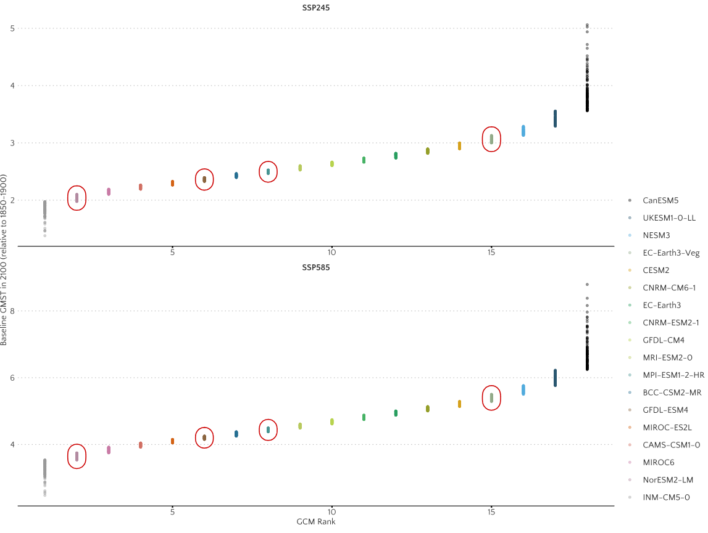

## Figure 2: CSIB Top 4 GCMs for U.S. (CONUS)

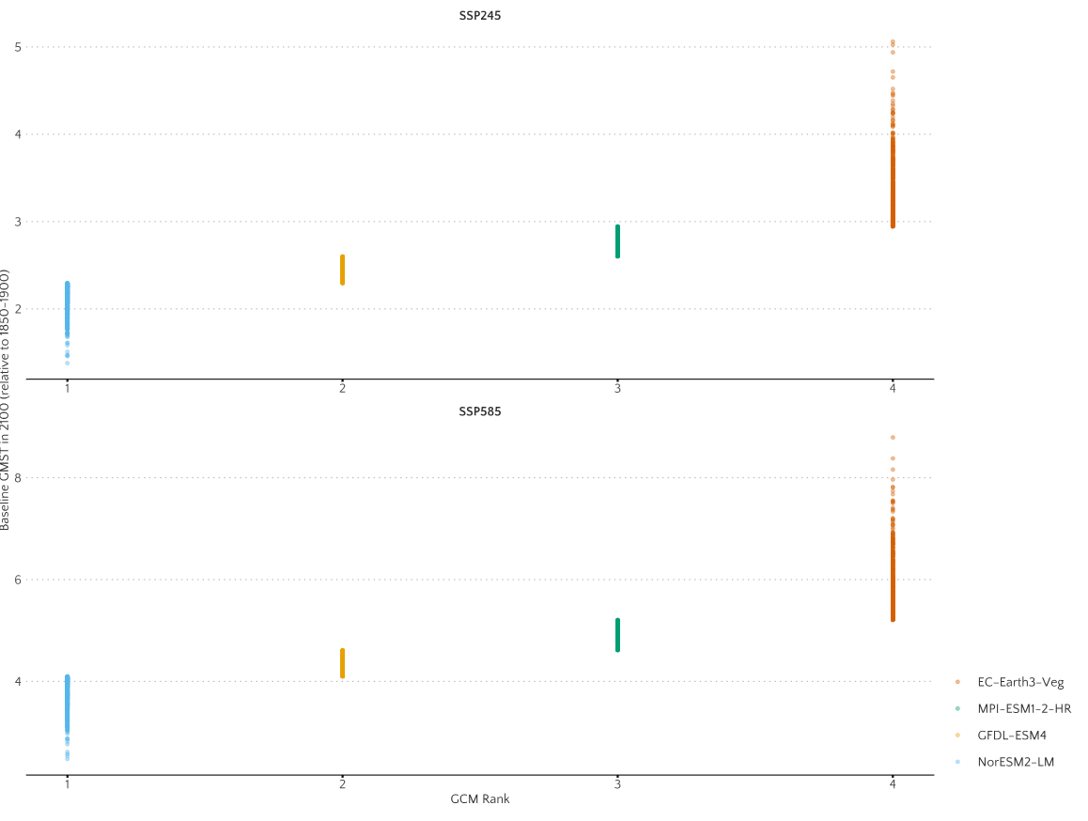

## Figure 3: Baseline GMST from FaIR and GCM Rankings

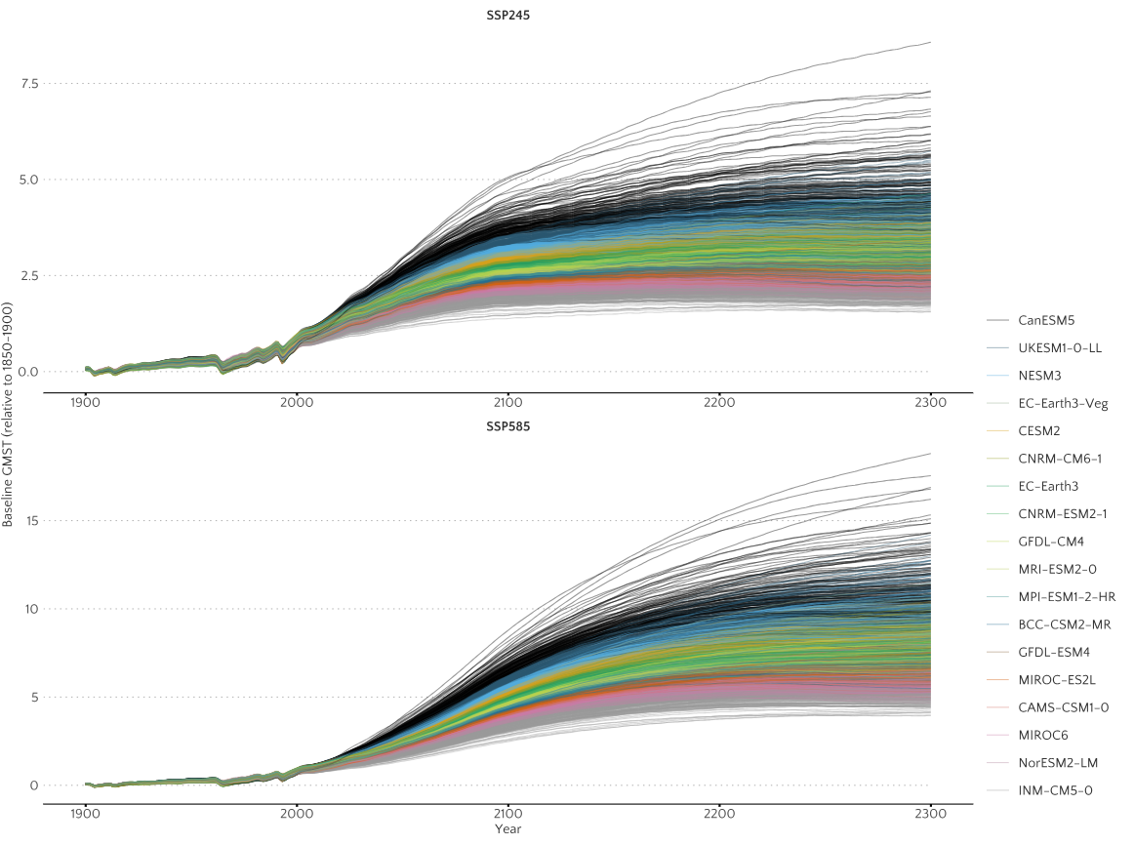

## Figure 4: Baseline GMST from FaIR and GCM Rankings based on CSIB Top 4 for U.S. (CONUS)

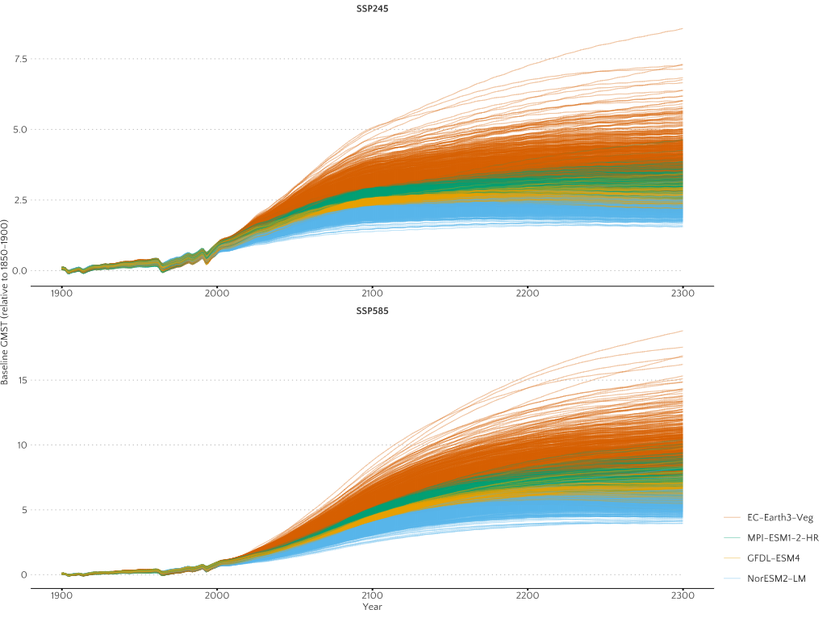

## References

Kravitz, B., Lynch, C., Hartin, C., and Bond-Lamberty, B. 2016. Exploring precipitation pattern scaling methodologies and robustness among CMIP5 models. Geosci. Model Dev. Discuss., doi:10.5194/gmd-2016-258.

Kravitz, Ben, & Snyder, Abigail. 2022. Pangeo-Enabled ESM Pattern Scaling (PEEPS): A customizable dataset of emulated Earth System Model output [Data set]. https://doi.org/10.5281/zenodo.7139978.

Lynch, C., Hartin, C., Bond-Lamberty, B., and Kravitz, B. 2017. An open-access CMIP5 pattern library for temperature and precipitation: Description and methodology, Earth Syst. Sci. Data Discuss., doi:10.5194/essd-2016-68, in review.

US EPA. Pattern Scaling of Global Climate Variables. 2023. https://github.com/usepa/pattern-scaled-climate-variables.

Errickson, Frank. 2023. A Julia-Mimi implementation of the FAIRv1_6_2 simple climate model. https://github.com/anthofflab/MimiFAIRv1_6_2.jl.

Tokarska, K.B., Stolpe, M.B., Sippel, S., Fischer, E.M., Smith, C.J., Lehner, F. and Knutti, R. 2020. Past warming trend constrains future warming in CMIP6 models. Science advances, 6(12), p.eaaz9549.

1. The deterministic pairing of the FaIR parameter sets with the EMS/GCM patterns can also be found in the `results` folder of this repository, under the file name `fair_parameter_sets_and_gcm_pattern_pairings.csv`